Going on an Airplane
I am going on vacation with my family. We are going on an airplane. At the airport we have to go through the TSA line. I have to put my iPad and maybe my shoes in a bin so they can be scanned. It is ok because I get then back.
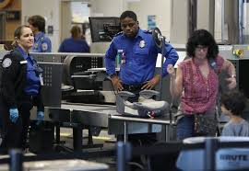
After the TSA line we wait and wait for the airplane to be ready.
When the airplane is ready, we walk onto the airplane down a long hallway then we get on the airplane.
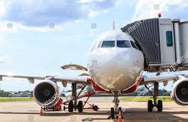
We must bucket out seatbelts on the airplane and stay in our seats unless we need to use the bathroom.

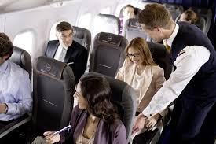

Before take-off, the airplane goes very fast down the runway and flies in the sky. Sometimes people’s ears feel funny on the airplane. If my ears feel funny I can pretend to yawn or pretend to blow bubbles.
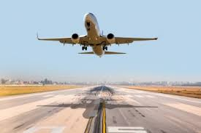
I will be on the airplane for a long time but I can look at books or play on my iPad. Sometimes people come around and give out drinks. I can get water or milk if I want.
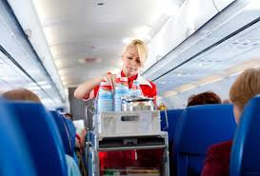
When the airplane lands the pilot puts the breaks on and the airplane may bump.
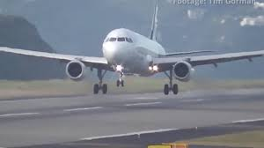
When the airplane lands I can go and see other people in my family.

